**ES Lab 1 Report**

**Introduction to Keil Vision**

Date: 8th January, 2025

Phirozgar Irani

230905370

CSE 4B: B2

Q1. ADDITION OF 2 DECIMAL NUMBERS

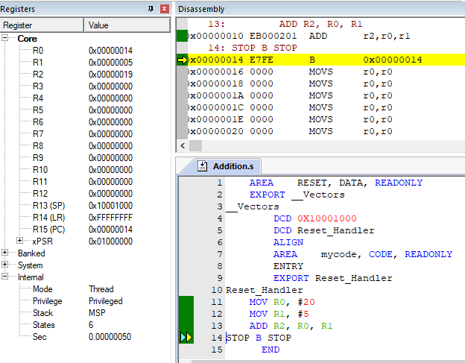

Q2. ADDITION OF 4 NUMBERS STORED IN R0, R1, R2, R3 AND STORE RESULT IN R10

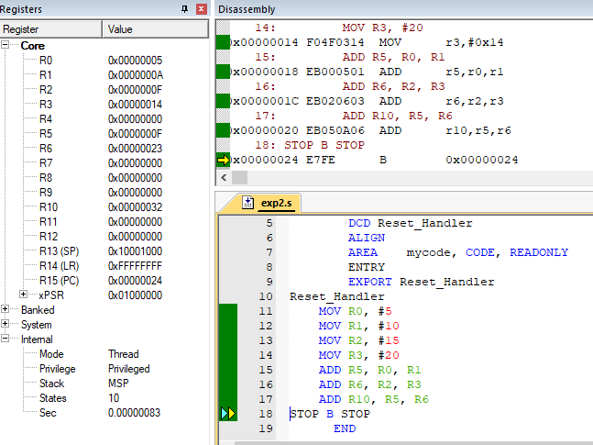­

Q3. SUBTRACT CONTENTS OF R8 FROM R7 AND STORE RESULT IN R10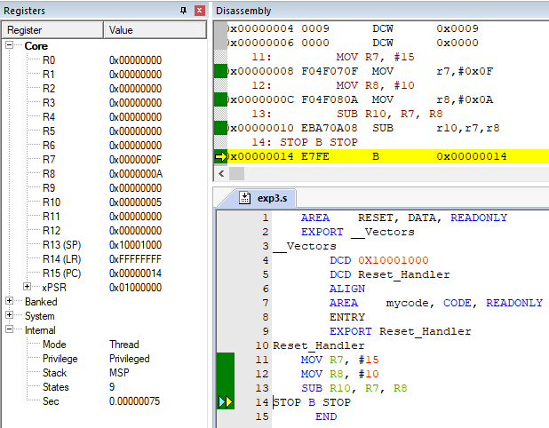

Q4. ADD 2 OCTAL NUMBERS

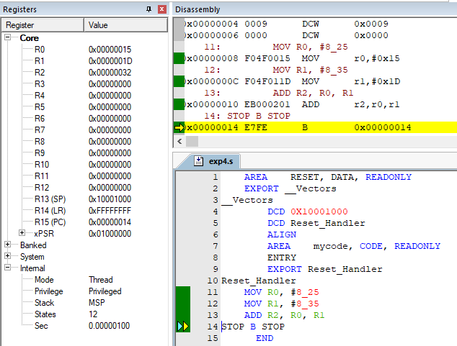

Q5. ADD 2 BINARY NUMBERS

